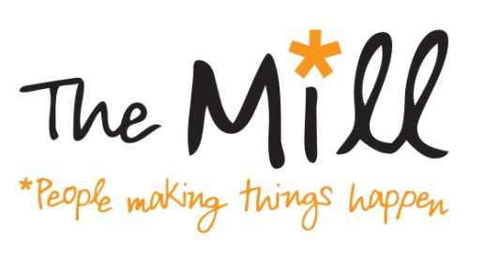
Equality and Diversity Monitoring Form

This information will be separated from you application and treated anonymously. Please bold or highlight the relevant boxes.

Gender:

Man | Woman | Non-binary | Prefer not to say

If you prefer to use your own term, please specify here:

Are you married or in a civil partnership?

Yes | No | Prefer not to say

Age:

16-24 | 25-29 | 30-34 | 35-39 | 40-44 | 45-49
50-54 | 55-59 | 60-64 | 65+ | Prefer not to say

What is your ethnicity?

Ethnic origin is not about nationality, place of birth or citizenship. It is about the group to which you perceive you belong.

White

English | Welsh | Scottish | Northern Irish
Irish | British | Gypsy or Irish Traveller | Prefer not to say

Any other white background, please specify here:

Mixed/multiple ethnic groups

White and Black Caribbean | White and Black African | White and Asian | Prefer not to say

Any other mixed background, please write in:

Asian/Asian British

Indian | Pakistani | Bangladeshi | Chinese | Prefer not to say

Any other Asian background, please write in:

Black/ African/ Caribbean/ Black British

African | Caribbean | Prefer not to say

Any other Black/African/Caribbean background, please write in:

Other ethnic group

Arab | Prefer not to say

Any other ethnic group, please write in:

