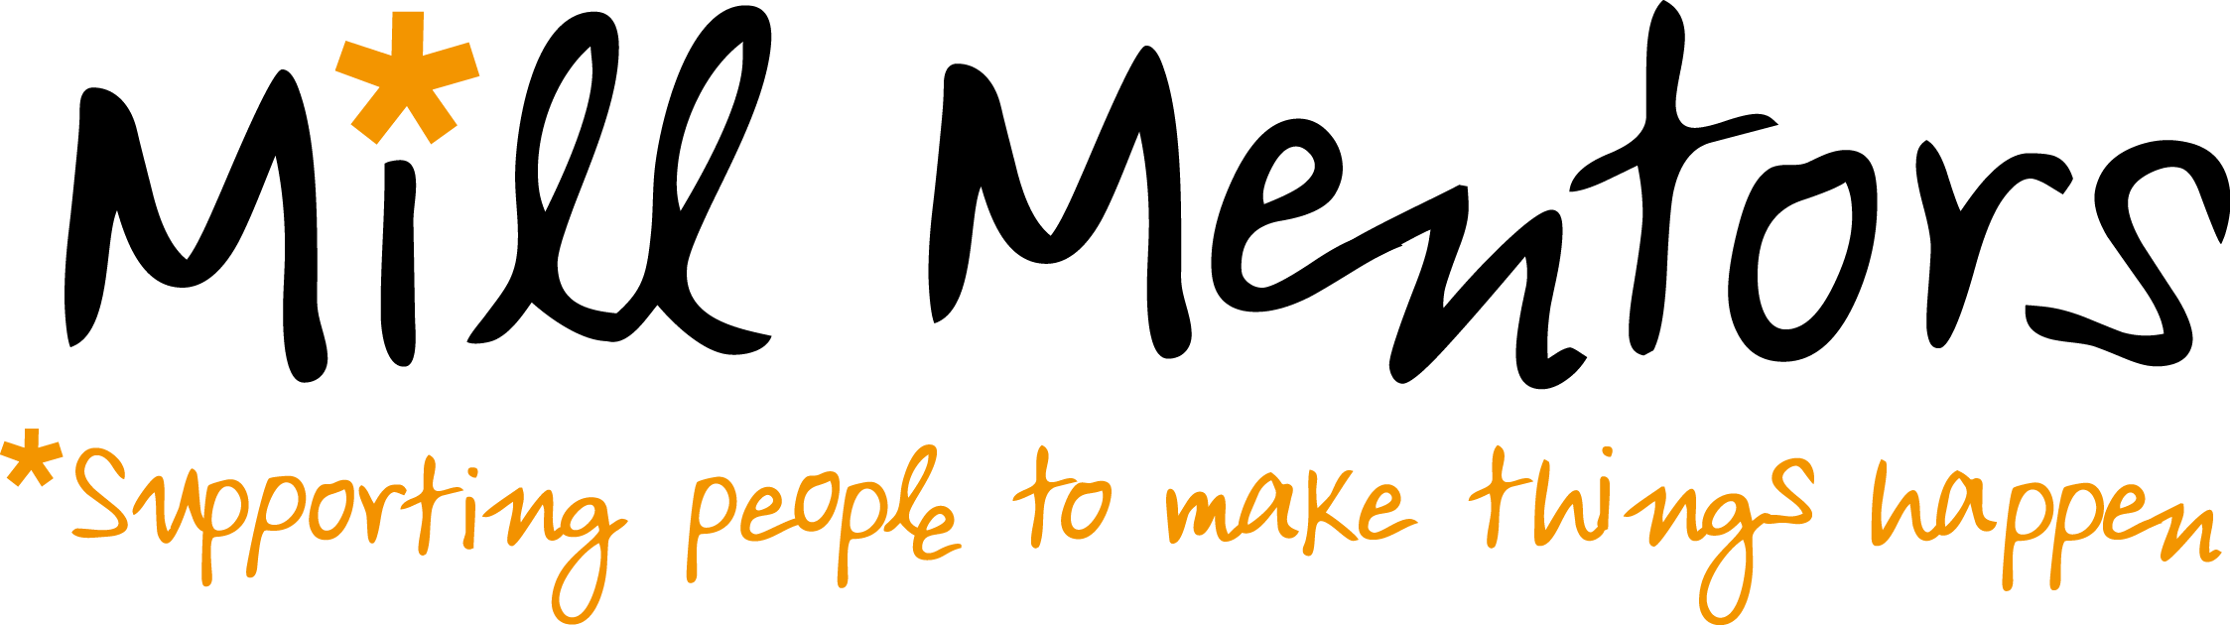
Your details
First name ....................................................................... Surname ................................................................................
Email address .................................................................................. Phone number ........................................................
Address........................................................................................................................................................................................................................................................................ Postcode .............................................................................

Your skills and experience
- Do you have any experience of mentoring?
Yes, I have been a mentor Yes, I have been mentored No, neither
2. What work or volunteering have you done? ........................................................................................................................................................................................................................................................................................................................................................................................

3. Which of the following do you feel confident in doing? Tick all that apply.

Giving advice about a topic I know well
Listening to others
Helping someone with a difficult decision
Helping someone work out what they want
Speaking up for someone
Public speaking
Planning a project
Planning an event
Making a budget
Helping to resolve conflicts between people

4. What are your talents? (telling jokes, playing a musical instrument, art, other languages...) ........................................................................................................................................................................................................................................................................................................................................................................................
........................................................................................................................................................................................................................................................................................................................................................................................
5. What are your interests and passions? (drama, local issues, the environment, faith, campaigning...)
........................................................................................................................................................................................................................................................................................................................................................................................
........................................................................................................................................................................................................................................................................................................................................................................................

6. What do you think you could bring to the role of Mill Mentor?
........................................................................................................................................................................................................................................................................................................................................................................................
........................................................................................................................................................................................................................................................................................................................................................................................

7. What interests you about becoming a Mill Mentor?
........................................................................................................................................................................................................................................................................................................................................................................................
........................................................................................................................................................................................................................................................................................................................................................................................

8. What do you want to gain out of the experience?
........................................................................................................................................................................................................................................................................................................................................................................................
........................................................................................................................................................................................................................................................................................................................................................................................

9. What is your time availability? Tick all that apply.
I’m available in the evenings I’m available during weekdays I’m available at weekends
Declaration
If selected as a Mill Mentor:
- I will attend the training sessions, contribute to the Mill Mentoring programme to the best of my ability and act according to The Mill’s values.
- I will keep in regular touch with my mentee and let the Mill Mentoring Coordinator know if I have any problems.

Signature: ................................................................................. Date: .............................................

