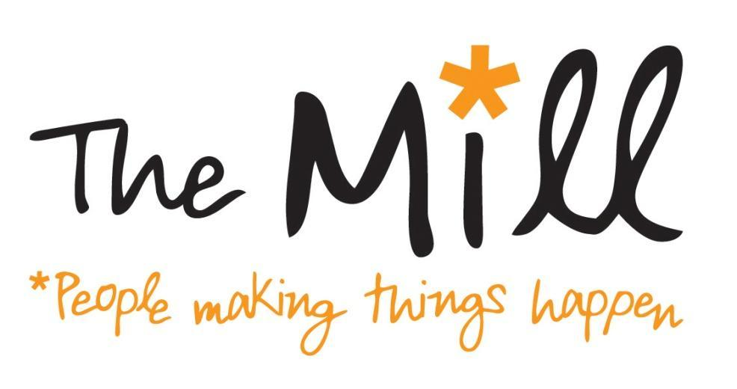

Opportunity to become a Trustee at the Mill

The Mill is an independent community hub at the heart of Walthamstow, dedicated to helping local people make the most of their talents and skills. We provide space so that local residents have the opportunity to run and attend events and classes and we rent office space to local businesses and charities. Our large living room, at the heart of The Mill, provides newspapers, tea and coffee and games. Our honesty library and children’s room are available for visitors.

Our strapline at the Mill is ‘People Making Things Happen’. This reflects our desire to help utilise and share local talent and the fact that we are largely run by volunteers along Asset Based Community Development (ABCD) principles.
The Mill was set up by the local community and opened its doors in 2011. We are at an exciting point in our journey. We are well established and well known throughout the area. We are also looking to the future, to strengthen and diversify our income and activities.

We are looking to grow our board to seven members and are looking to recruit up to four new Trustees.

The Trustee role

The Trustee role at the Mill is varied and interesting, covering governance of the organisation and strategic development. Trustees also are expected to take an active role in both staff/volunteer liaison and operational matters, both face-to-face and over email. As Trustees we volunteer to

- Take the big decisions about the future of the Mill
- Set the framework for staff and volunteers to support them in achieving our objectives
- Ensure the Mill complies with the law and regulatory requirements
- Safeguard the Mill’s assets.

What we are looking for

We are looking for individuals who can volunteer at least 3 hours a week to the Mill.

Trustee meetings currently take place once a month in the evening (currently the first Tuesday of the month from 7.30 - 10pm).
- ect
We are keen to have a Trustee board that reflects the diverse community in which the Mill runs. We are looking for enthusiasm and your commitment of skills and time. We are particularly looking for individuals with experience or expertise in the following areas:

- Human Resources
- Fundraising
- Community Links in Waltham Forest, which could include links with other charities, the third sector, the council or local business
- Finance
- Communications
- Building management or development - to help us work towards our longer term goal of developing our building.

The Mill is moving to a new ‘working group’ management structure, combining staff, Trustees and other volunteers. Trustees will be expected to be involved in one of the following groups:

- Core operations
- Strategic development
- Financial Sustainability
- People - covering both staff and volunteers
- Strategic communications

Previous experience of being a Trustee is not required. We ask Trustees to commit to at least a year with the Mill.

The roles of Chair, Secretary and Treasurer are currently filled, though we are looking to appoint a new Chair in early 2016 to lead the Board.

Application

We are holding an open day on Saturday 19th September at the Mill. If you would like to become a Trustee at the Mill please come along any time between 10 and 1 to meet staff, volunteers and Trustees. Please bring a copy of your CV and we will ask you to complete a short questionnaire when you arrive. If selected to join the Board, references will be requested.

If you have any questions please contact Kate Masri kate@themill-coppermill.org

