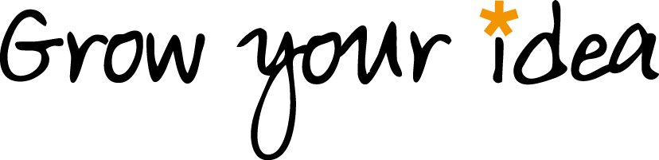

Grant Application Form

About you:
First Name
Last Name
Phone Number
Email address
Postal address & postcode

About your idea:
1. My group or activity will: (tick all that apply)
- Help local people connect with each other
- Encourage local people to share their experiences, skills and/or knowledge
- Help local people to feel more confident about themselves and their abilities

2. What’s your idea? Describe what you want to do in a few sentences.

3. What makes you passionate about this idea?

4. Who will benefit from your idea, and how?

5. Will the following people take part in your activity or group? Tick all that apply
- Children under 18
- Vulnerable adults
6. Our specially trained Mill Mentors will be able to help you think through and develop your idea. Which of these would you most like help with? Tick all that apply
- Planning the content of the sessions
- Promoting and advertising my group or activity
- Making a budget and finding additional funding
- Keeping people safe
- Troubleshooting
- Monitoring my progress and demonstrating my success

Declaration:
I declare that this grant will be used in good faith to deliver the project described above, and I will work with The Mill to provide feedback on the success of my idea.
Date:

Signature:

Print name:

Please email the completed form to grants@themill-coppermill.org
or hand it in to The Mill, 7-11 Coppermill Lane, London E17 7HA.
The deadline for applications is 5pm on Friday 28th March.
We won’t be able to consider applications submitted after that date.

